Experiment No.08
Title: Analysis of multipath effects (signal fluctuation observation).

Aim: To observe and analyze the effect of multipath propagation on received wireless signal strength by measuring signal fluctuations at different receiver positions.
Requirement:

Hardware
• Wi-Fi router/access point
• Laptop with Wi-Fi adapter
• Measuring tape
• Open laboratory space
• Obstacles/walls in the environment

Software
• Python 3.x
• Matplotlib
• NumPy

Theory :

Multipath Propagation
In wireless communication, a transmitted radio signal may reach the receiver through multiple paths.
This occurs because radio waves can undergo:
- Reflection
- Diffraction
- Scattering
As a result, the receiver may receive several copies of the same transmitted signal at slightly different times.
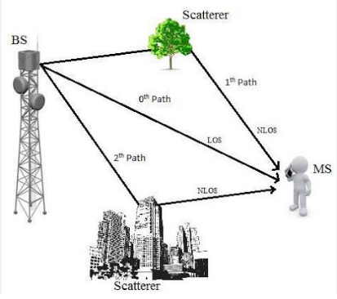
The receiver therefore receives the signal through different paths.

Multipath Signal
The received signal can be considered as the combination of multiple signal components:
r(t)=i=1∑n​Ai​s(t−τi​)
where:
- Ai​ = amplitude of the signal arriving through path i
- τi​ = delay associated with path i
- s(t) = transmitted signal
- r(t) = received signal
Because the different signal components can have different phases, they may either reinforce or cancel one another.

Multipath Fading
The rapid variation in received signal strength caused by multipath propagation is called multipath fading.
A receiver may therefore observe:
Position → 1 2 3 4 5 6 7 8

Signal → -45 -48 -42 -55 -47 -63 -50 -44
Even though the transmitter has not changed its power, the measured signal can fluctuate considerably.

Causes of Multipath
Multipath is commonly caused by:
- Buildings
- Walls
- Furniture
- Vehicles
- Metal objects

Procedure

Step 1 — Setup
- Place the Wi-Fi router at a fixed location.
- Connect the laptop to the router.
- Keep the router stationary throughout the experiment.
- Select a measurement path in the laboratory.
- Mark positions at regular intervals, for example:
  - 1 m
  - 2 m
  - 4 m
  - 6 m
  - 8 m
  - 10 m

Step 2 — RSSI Measurement
- Place the laptop at the first position.
- Measure the Wi-Fi signal strength.
- Record the value.
- Take at least three readings at each position.
- Calculate the average RSSI.
- Move the laptop to the next position.
- Repeat the measurement.
- Continue until all positions have been measured.

Measuring Wi-Fi Signal on Windows
Open Command Prompt and enter:
netsh wlan show interfaces
The output may contain:
Signal : 82%
Windows normally reports the Wi-Fi signal as a percentage.
For this experiment, a Wi-Fi analysis tool that directly provides signal strength in dBm is preferable if available.

Program

import matplotlib.pyplot as plt

import numpy as np

# Distance from router in metres

distance = np.array([1, 2, 3, 4, 5, 6, 7, 8])

# Average RSSI obtained from experiment

rssi = np.array([-45, -49, -43, -55, -47, -62, -51, -46])

plt.figure(figsize=(9, 5))

plt.plot(

distance,

rssi,

marker='o',

linewidth=2

)

plt.xlabel("Distance from Router (m)")

plt.ylabel("Average RSSI (dBm)")

plt.title("Analysis of Multipath Effects")

plt.grid(True)

# More negative RSSI = weaker signal

plt.gca().invert_yaxis()

plt.show()

Expected Output
The graph should show fluctuations in received signal strength.
RSSI (dBm)

-40 | ●
-45 | ● ● ●
-50 | ● ●
-55 | ●
-60 | ●
|
+------------------------------
1 2 3 4 5 6 7 8

Distance (m)
The important feature is that the RSSI does not necessarily follow a smooth decreasing curve.

Output

Applications
Multipath analysis is useful in:
- Wi-Fi network planning
- 4G/LTE networks
- 5G networks
- Wireless Sensor Networks
- IoT networks
- Indoor positioning
- Mobile communication

Conclusion: Multipath-induced fluctuations in received wireless signal strength were successfully observed. The experiment demonstrated the effects of constructive and destructive interference on the received Wi-Fi signal.

